|  |  |  |  |  |  |  |  |
| --- | --- | --- | --- | --- | --- | --- | --- |
| PIN OUT ARDUINO | PIN OUT I2C LCD 16x2 | Buzzer | LED Hijau | LED Merah | PIN OUT Sensor GAS MQ-2 | SIM800L | ESP-01 8266 |
| SDA (A4) | SDA | - | - | - | - |  |  |
| SCL (A5) | SCL | - | - | - | - |  |  |
| VCC (5V) | VCC | - | - | - | (+) | (+) |  |
| VCC (3.3 V) |  |  |  |  |  |  | VCC, Ch_PD |
| GND | GND | (-) | (-) | (-) | (-) | (-) | (-) |
| 2 |  |  |  |  |  |  | TXD |
| 3 |  |  |  |  |  |  | RXD |
| 7 | - | - | - | - | - | RXD |  |
| 8 | - | - | - | - | - | TXD |  |
| 9 | - | - | - | (+) | - |  |  |
| 10 | - | - | (+) | - | - |  |  |
| 11 | - | (+) | - | - | - |  |  |
| 12 | - | - | - | - | (D0) Digital Output |  |  |

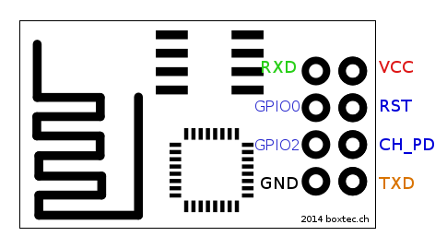ESP-01 8266